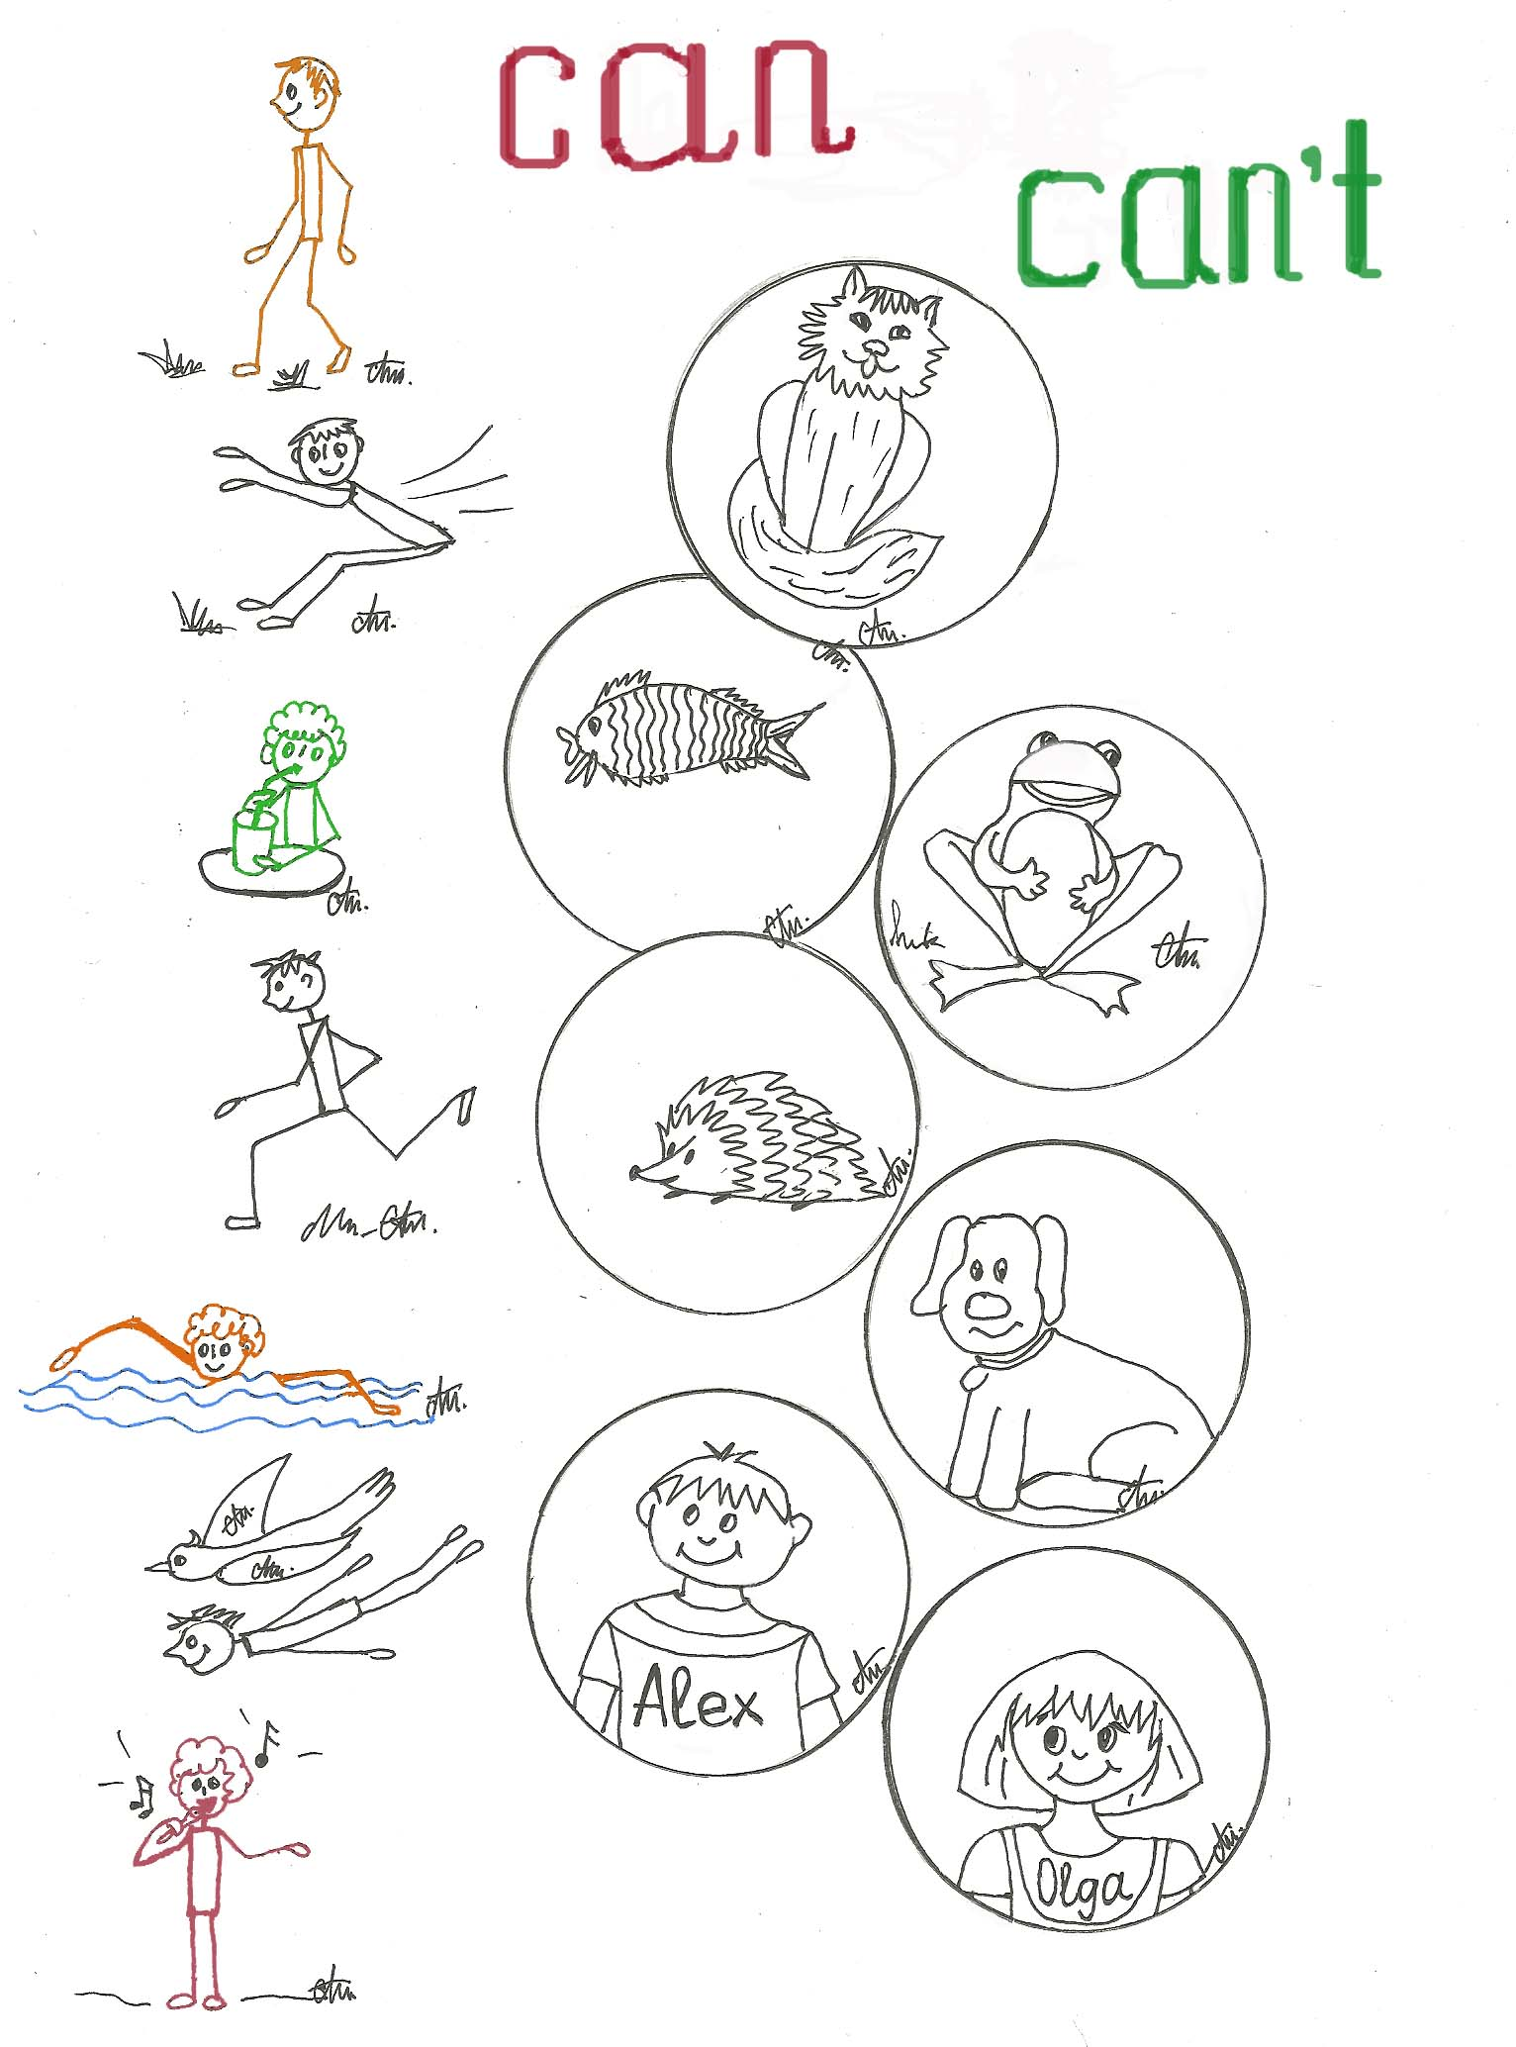
can’t
Can
© С.А. Ткаченко 2010

Must and Mustn’t

4. Что должны делать:

read a book, go to the shop with dogs, do homework, eat a lot, put mugs on a book, help mum and dad, smoke, be late for sghool, lock the door
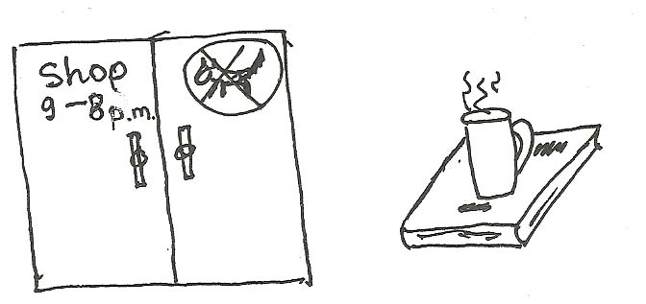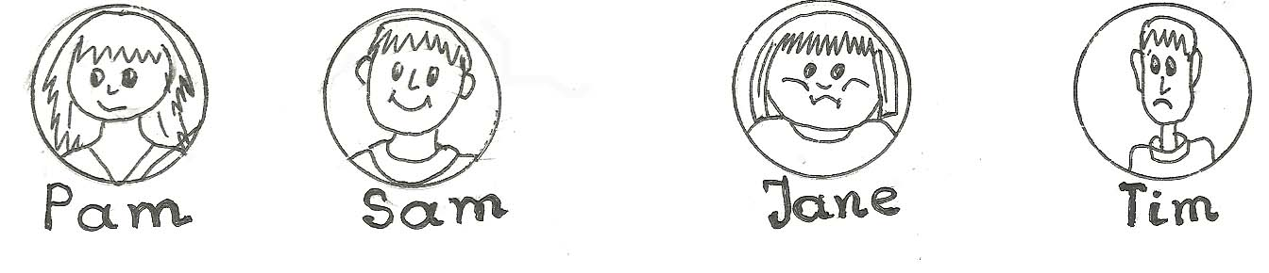
Must:
...........................................................................................................
...........................................................................................................
...........................................................................................................
...........................................................................................................
...........................................................................................................
...........................................................................................................
Mustn’t
...........................................................................................................
...........................................................................................................
...........................................................................................................
...........................................................................................................
...........................................................................................................
...........................................................................................................
...........................................................................................................

5. В квартире Димы есть запретительные знаки. Догадайся об их значении и запиши. Придумай свои, нарисуй и запиши.
talk, swim, sing, touch, keep silent 